Lab 3: Torque Control of Permanent-Magnet Synchronous Motors

Connor Ricotta

400199761

# Introduction:

# Results:

## Part 1: ZeroID

|  |  |
| --- | --- |
| Motor Efficiency (%) | 93.59 |
| Power Extracted (Pbat) | 51.56 |
| Average Torque | 192 |
| SS Trq Ripple | 0.004078 |
| U Control Load | 0.00471 |
| Current THD | 0.05156 |
| Torque Tracking Error | 0.0136 |

## MTPA Control:

|  |  |
| --- | --- |
| Motor Efficiency (%) | 95.86 |
| Power Extracted (Pbat) | 50.31 |
| Average Torque | 191.9 |
| SS Trq Ripple | 0.02252 |
| U Control Load | 0.005088 |
| Current THD | 0.04193 |
| Torque Tracking Error | 0.1048 |

## MTPA Control: Gain applied to PsiF

|  |  |
| --- | --- |
| Motor Efficiency (%) | 96.14 |
| Power Extracted (Pbat) | 43.7 |
| Average Torque | 167.2 |
| SS Trq Ripple | 0.02448 |
| U Control Load | 0.006085 |
| Current THD | 0.04702 |
| Torque Tracking Error | 24.71 |

## MTPA Control: Step Change

|  |  |
| --- | --- |
| Motor Efficiency (%) | 95.39 |
| Power Extracted (Pbat) | 63.19 |
| Average Torque | 239.9 |
| SS Trq Ripple | 0.02619 |
| U Control Load | 0.00407 |
| Current THD | 0.03741 |
| Torque Tracking Error | 0.02755 |

(within response time)

## MTPA Control: Sinusoidal

|  |  |
| --- | --- |
| Motor Efficiency (%) | 95.73 |
| Power Extracted (Pbat) | 49.65 |
| Average Torque | 191.1 |
| SS Trq Ripple | 0 |
| U Control Load | 0.003717 |
| Current THD | 12.51 |
| Torque Tracking Error | 11.74 |

## MPC Control: Positive Gain / Step Change

|  |  |
| --- | --- |
| Motor Efficiency (%) | 95.49 |
| Power Extracted (Pbat) | 61.24 |
| Average Torque | 232.2 |
| SS Trq Ripple | 7.338 |
| U Control Load | 0.009067 |
| Current THD | 9.784 |
| Torque Tracking Error | 176.7 |

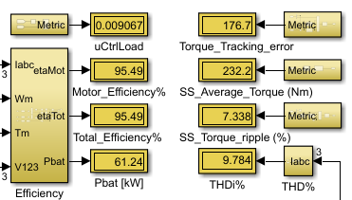

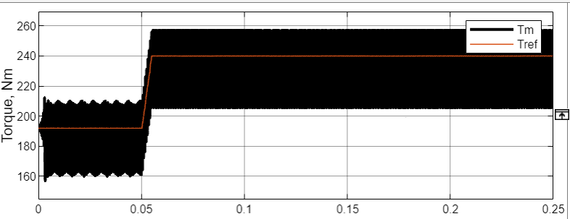

## MPC Control: Positive Gain / Sinusoidal

|  |  |
| --- | --- |
| Motor Efficiency (%) | 95.79 |
| Power Extracted (Pbat) | 46.77 |
| Average Torque | 180.1 |
| SS Trq Ripple | 0 |
| U Control Load | 0.008738 |
| Current THD | 20.78 |
| Torque Tracking Error | 22.22 |

## MPC Control: Negative Gain / Step Change

|  |  |
| --- | --- |
| Motor Efficiency (%) | 95.39 |
| Power Extracted (Pbat) | 63.19 |
| Average Torque | 239.9 |
| SS Trq Ripple | 0.02619 |
| U Control Load | 0.006978 |
| Current THD | 0.03741 |
| Torque Tracking Error | 0.02078 |

## MPC Control: Sinusoidal / Negative Gain

Deadbeat sinusoidal ref, negative gain

|  |  |
| --- | --- |
| Motor Efficiency (%) | 95.76 |
| Power Extracted (Pbat) | 49.7 |
| Average Torque | 191.2 |
| SS Trq Ripple | 0 |
| U Control Load | 0.005472 |
| Current THD | 15361 |
| Torque Tracking Error | 11.34 |

## VSI: 10khz / Step Change

VSI part 1, step change, 10khz

|  |  |
| --- | --- |
| Motor Efficiency (%) | 95.38 |
| Total Efficiency | 91.6 |
| Power Extracted (Pbat) | 51.56 |
| Average Torque | 192 |
| SS Trq Ripple | 0.004078 |
| U Control Load | 0.00471 |
| Current THD | 0.05156 |
| Torque Tracking Error | 0.0136 |

w

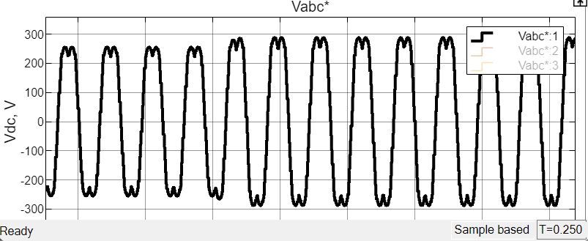

## VSI: 5KHz / Step Change

5khz: *simulation fails at 0.1 sec*

|  |  |
| --- | --- |
| Motor Efficiency (%) | 95.38 |
| Total Efficiency | 91.6 |
| Power Extracted (Pbat) | 51.56 |
| Average Torque | 192 |
| SS Trq Ripple | 0.004078 |
| U Control Load | 0.00471 |
| Current THD | 0.05156 |
| Torque Tracking Error | 0.0136 |

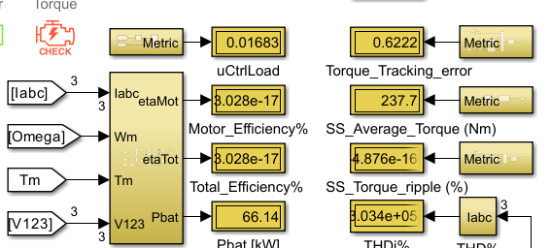

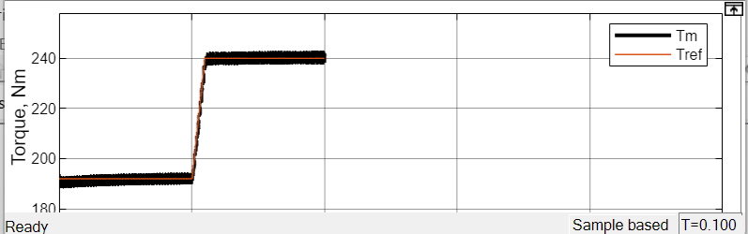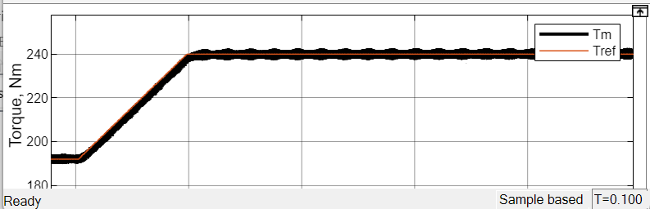

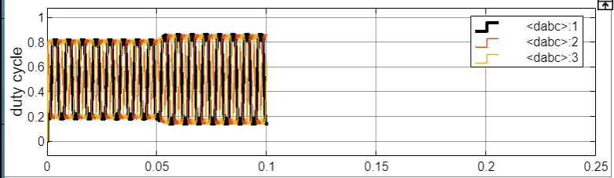

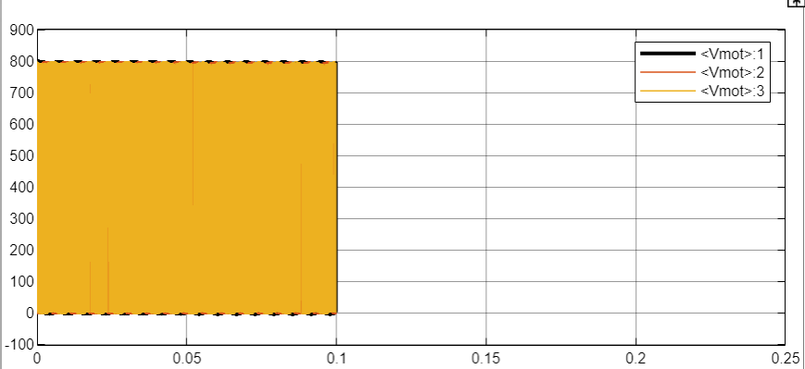

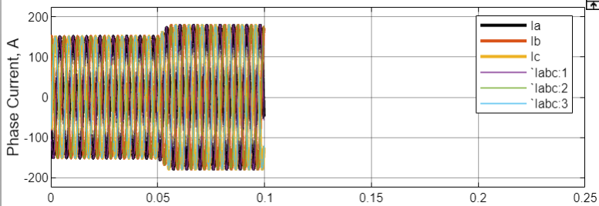

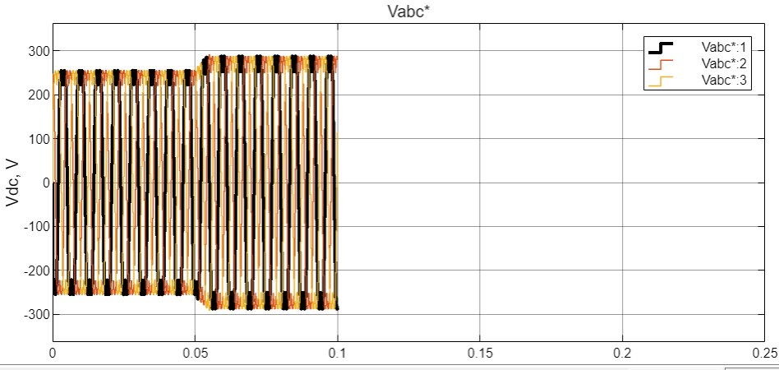

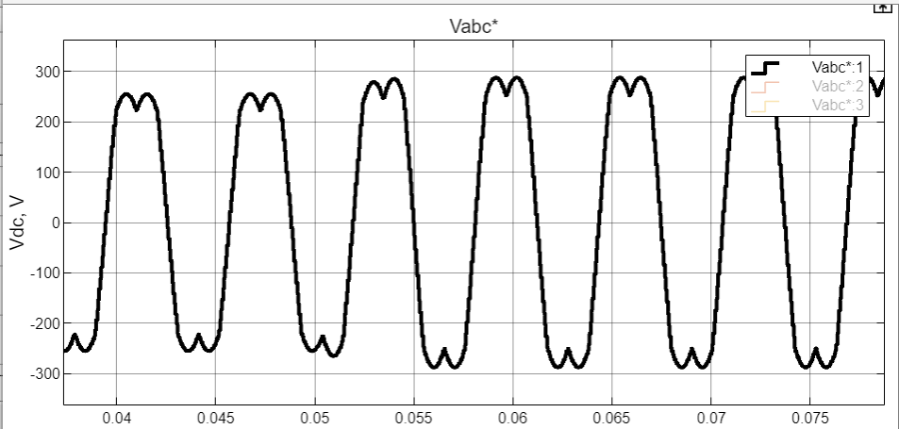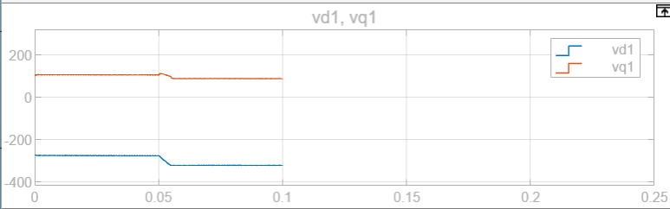

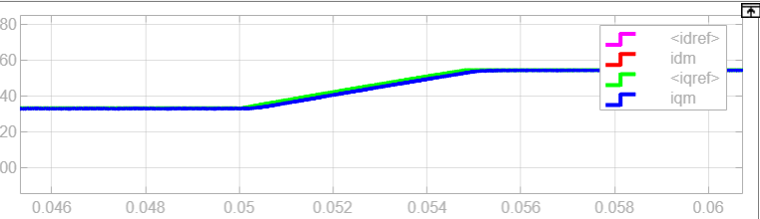

## VSI: 20KHz / Step Change

20khz:

|  |  |
| --- | --- |
| Motor Efficiency (%) | 95.38 |
| Total Efficiency | 92.25 |
| Power Extracted (Pbat) | 65.63 |
| Average Torque | 241 |
| SS Trq Ripple | 1.622 |
| U Control Load | 0.005069 |
| Current THD | 2.011 |
| Torque Tracking Error | 7.981 |

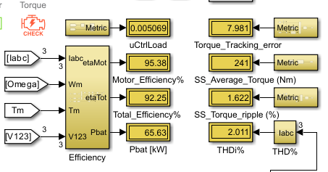

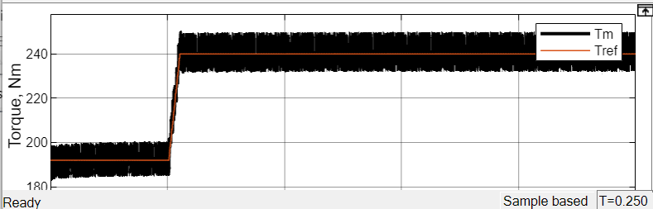

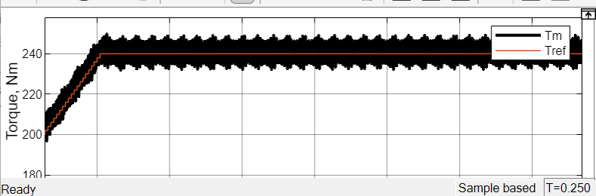

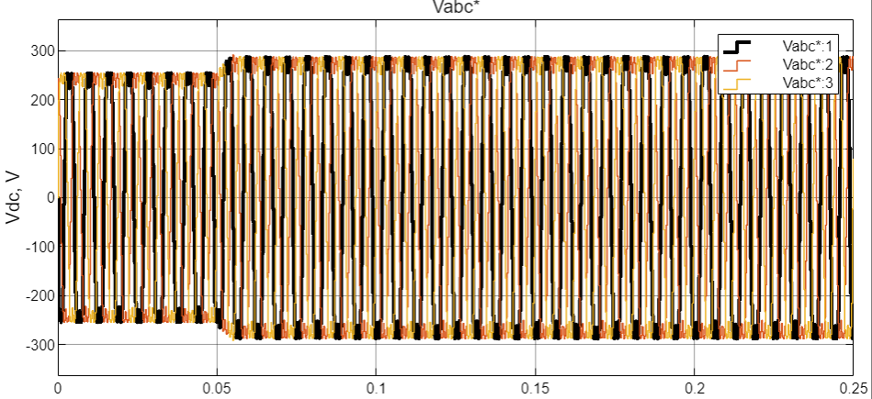

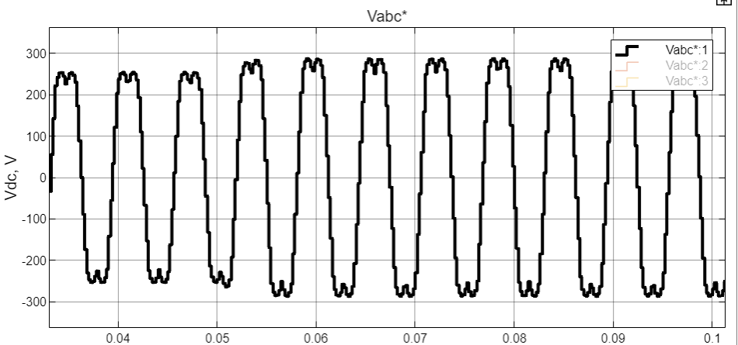

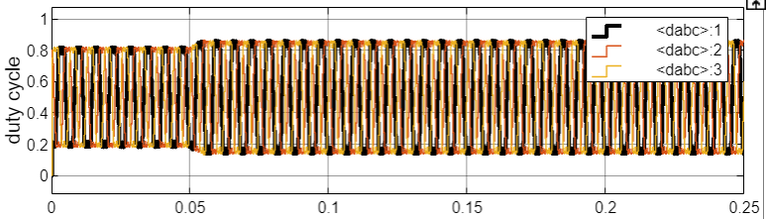

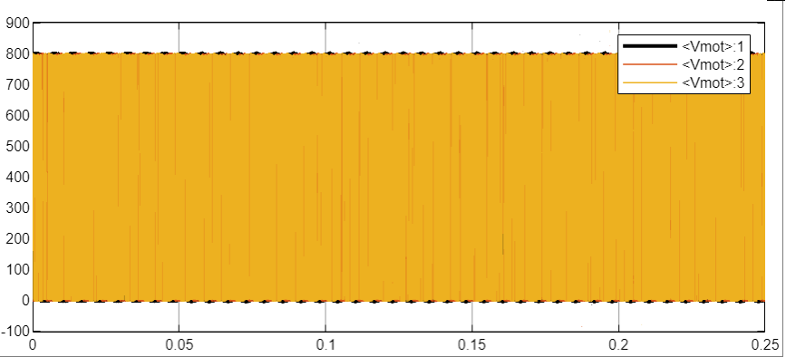

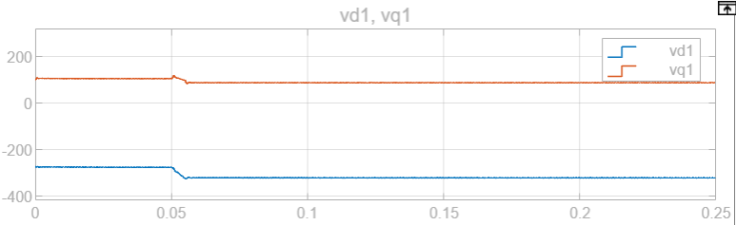

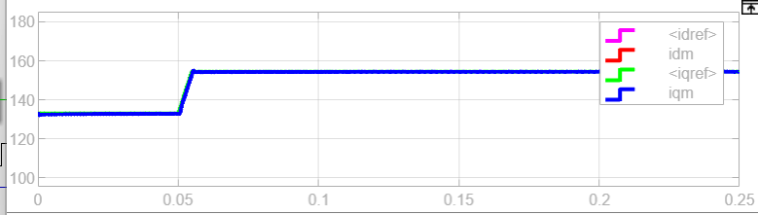

## VSI: 10KHz / Step Change / VDC/2

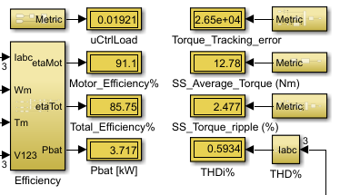

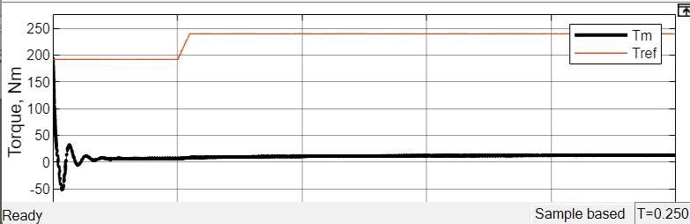

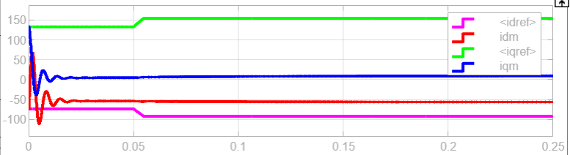

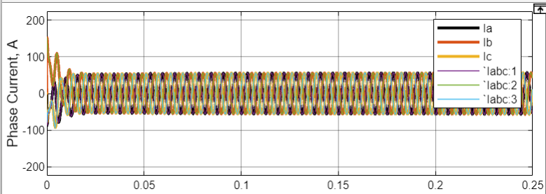

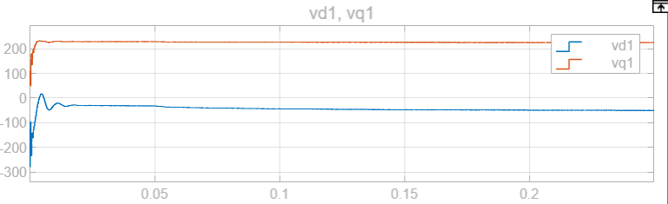

# Conclusion: